Report for Assignment 3
RRT with Kinematic Constraints
Bicycle Model Implementation
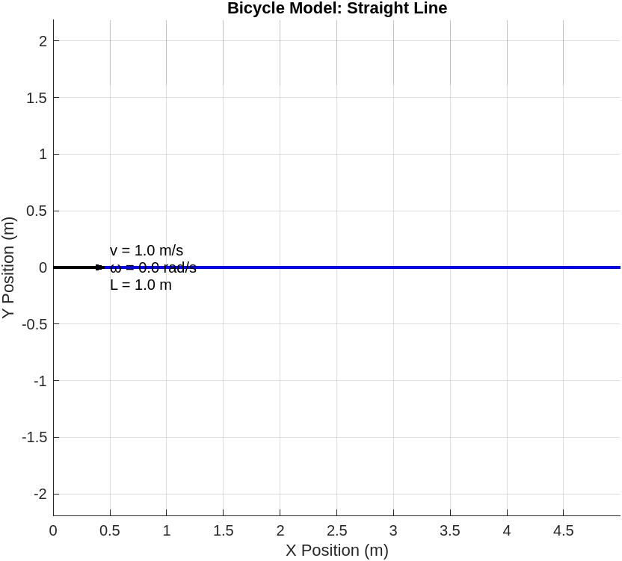 | 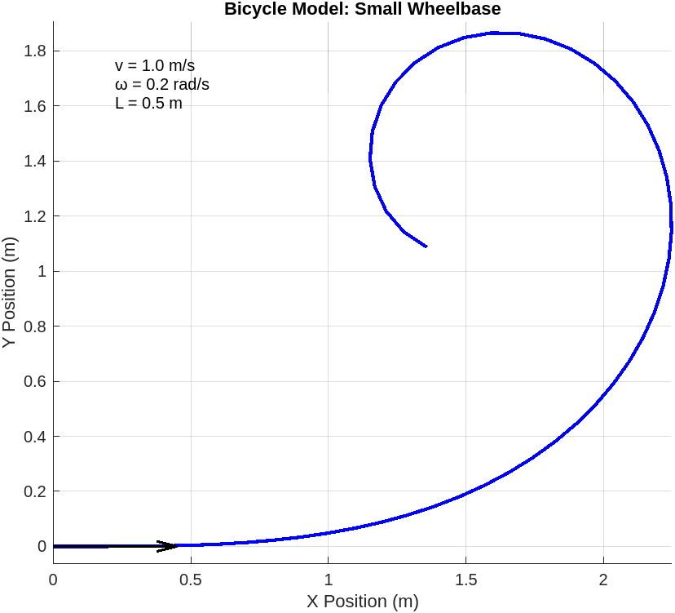
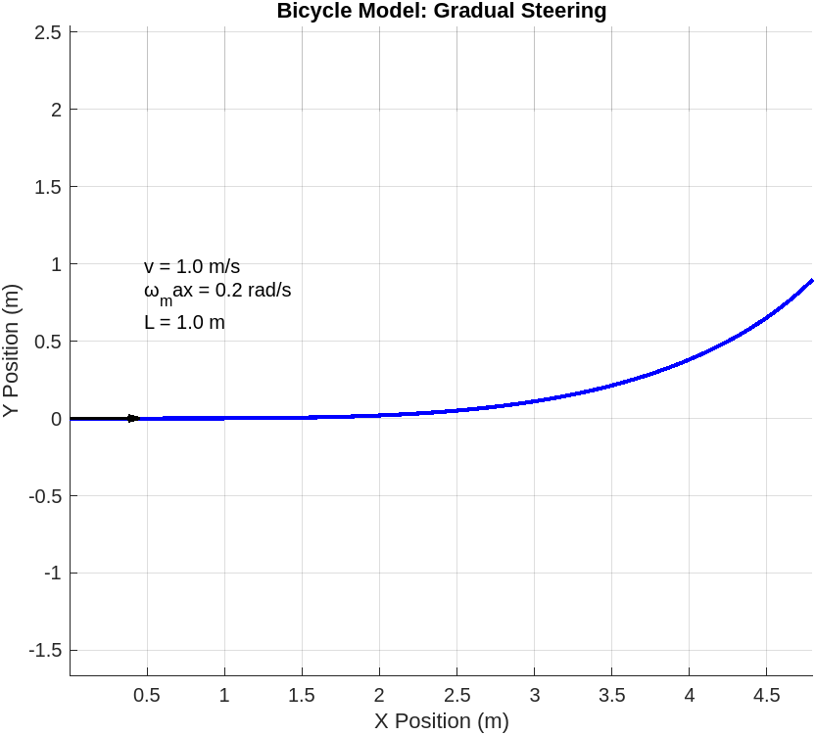 | 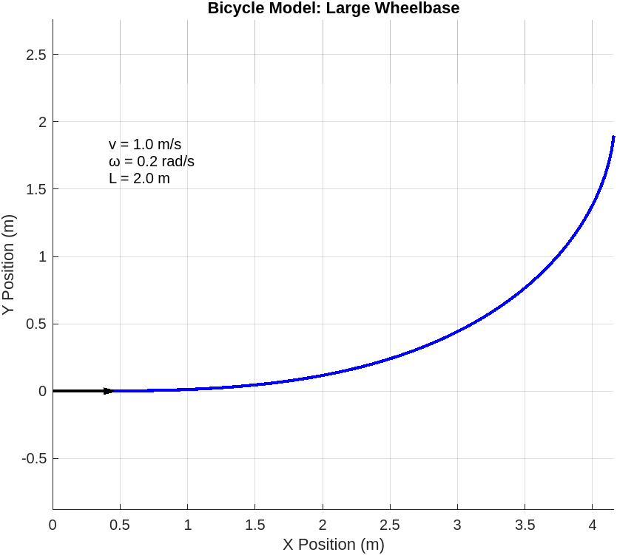
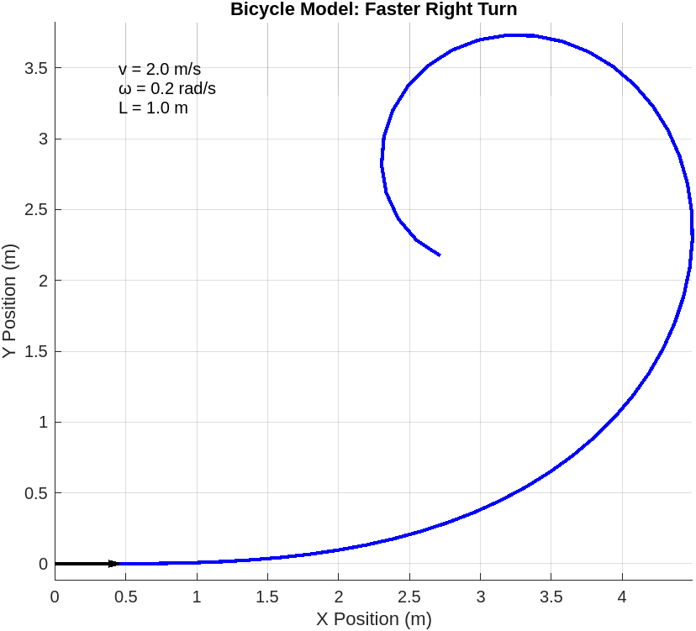
Answers to Questions:
Q1 - What happens when the velocity is constant with increasing steering angle?
A1 - The path becomes less bent than constant input steering angle.
Q2 - What happens when steering angle is negative?
A2 - The path curves in the opposite direction (left instead of right), meaning the sign signifies the direction.
Q3 - What happens with wheelbase (L) length effects (smaller/larger)?
A3 - Smaller L means tighter turning radius, Larger L means wider turning radius
Q4 – How to ensure numerical stability in the integration process?
A4 - Using small dt (0.1s) ensures stability, or using the 4th order Runge-Kutta Integrator [see refs].
Side Note: 4th order because to find the solution of a differential equation is the RK4 method. The Runge-Kutta method provides the approximate value of y for a given point x. Only the first order ODEs can be solved using the Runge Kutta RK4 method.)
RRT with Incorporated Kinematics
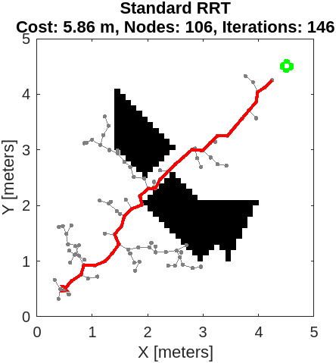 | 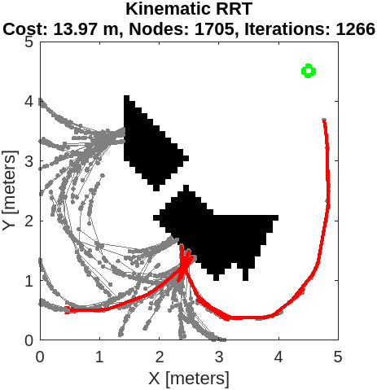
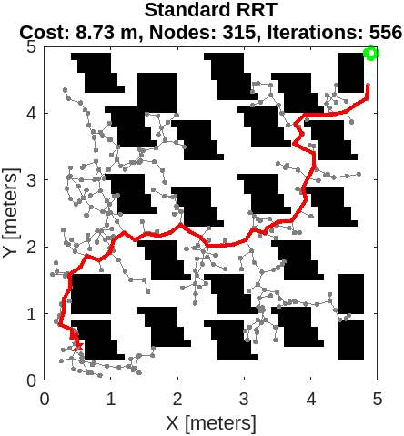 | 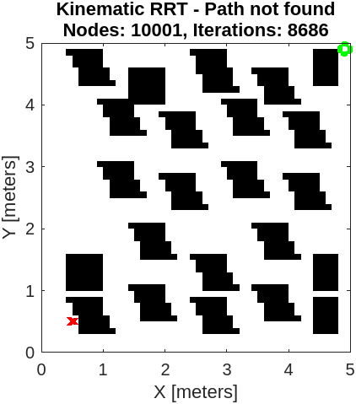

As you can see the Kinematic constrained RRT takes too much iteration and node exploration to arrive to the goal; that is if only it can do it under the kinematic constraints, as noticed in the second row, in a cluttered map it takes very significant computation and at the end it doesn’t achieve a path.
Side Note: RRT* cannot be used for incorporating kinematics constraint because when RRT* optimizes previously built path (meaning from start to current, not from current to new) the update doesn’t respect the kinematics of the robot (otherwise we would need to reconsider the whole path again and again, very slow and computation intensive)

References:
- Their majesty LLMs :) (ChatGPT, Grok), at the beginning of the assignment, then decided to use it just for map generation and plotting
- The valuable Matlab tutorials on path planning:
  - https://www.mathworks.com/help/nav/ref/plannerrrt.html
  - https://www.mathworks.com/help/nav/ref/plannerprm.html
  - https://fr.mathworks.com/help/nav/ref/statesamplergaussian.html#d126e139913
  - https://fr.mathworks.com/help/nav/ref/validatoroccupancymap.html
  - https://fr.mathworks.com/help/nav/ref/nav.statespace-class.html?lang=en
  - https://fr.mathworks.com/help/nav/ug/plan-mobile-robot-paths-using-rrt.html
  - https://fr.mathworks.com/help/nav/motion-planning.html?s_tid=CRUX_lftnav
  - https://fr.mathworks.com/help/nav/ref/mobilerobotpropagator.html
- Runge-Kutta Integrator:
  - https://byjus.com/maths/runge-kutta-rk4-method/#:~:text=The%20most%20commonly%20used%20Runge,the%20Runge%20Kutta%20RK4%20method.
  - https://www.youtube.com/watch?v=HOWJp8NV5xU

